The Gang or a Ring?
  It is Spring. Sally is happy. She began to sing a song. | Ted adores pretty Sally.  They are close friends.  Ted asks Sally to marry him.  “Sally, be mine.”
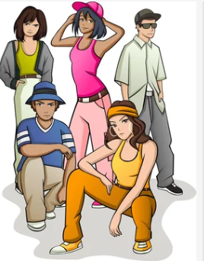  Sally cares for her friend Ted, yet he is in a bad gang. She tells Ted to go.  “I can’t stand it! Gangs are bad!” |   Ted is sad. Ted is mad!  “This is all a big mistake! I left the gang! The gang is no more!”
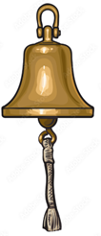  Time passes. A bell hanging from a long string rings “ding-a-ling”.  Bang! Clang! | 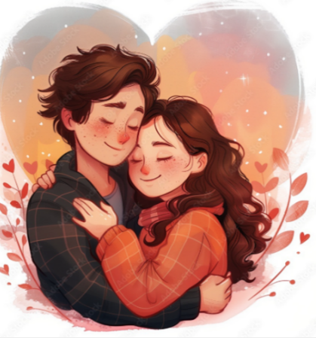  Ted has come back to bring Sally a ring. No more gang! They can marry.  “Sally is mine!”

Word List
1 |  | sing
2 | 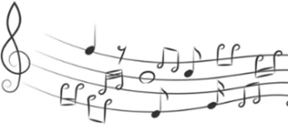 | song
3 |  | hang
4 |  | string
5 |  | ring
6 |  | angry
7 |  | long
8 | 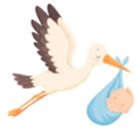 | bring
9 |  | bang
10 |  | clang
11 |  | gang
12 |  | pretty

Matching Game
Preparation: Cut out the squares on the dotted lines.
To play: match the words, placing them together (the edges of their squares touching). Assemble the puzzle into a 3X3 square so that every word only touches a matching word.

mistake  bang  hang  angry | ring  clang  bang  long | bring  clang  hang  song
angry  gang  adore  string | long  happy  gang  pretty | song  adore  happy  marry
string  sing  bell  mistake | pretty  time  bell  ring | marry  sing  time  bring

Online game: https://wordwall.net/resource/108296653
Match the word to its Hebrew definition.

