The Ox and the Fox in the Box
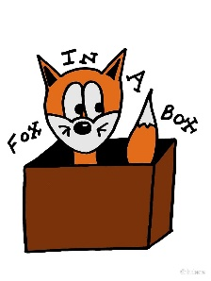  The fox sat in the box. | The box was next to an ox.
The ox gave the fox pox. | The ox vexes the fox, for he didn’t like being sick with pox.
The ox felt bad. He pats the fox's back six times.  6 | The fox was happy again.

Word List
1 | 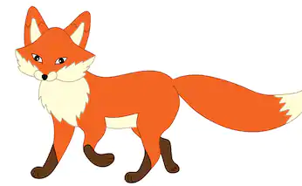 | fox
2 |  | ox
3 |  | pox
4 |  | box
5 | 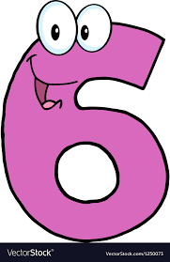 | six
6 |  | mix
7 |  | fix
8 | 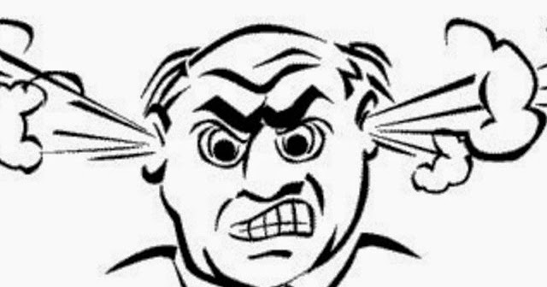 | vex
9 |  | next
10 |  | exam
11 |  | taxi
12 | This is text in a text box. It is a lot of words without pictures. | text

Matching Game 3x3 Puzzle

This is a more sophisticated form of “concentration” because it includes a self-check and hints on words that the learner doesn’t know.
Preparation: Cut out the squares on the dotted lines only (don’t cut out the triangles).
Play: match the words to their meanings, placing them together (the edges of their squares touching). Assemble the puzzle into a 3X3 square so that every word touches its definition.
(There are lots of right ways to assemble the puzzle, since the words at the top and bottom of each column and both ends of each row also rhyme.)
6  מלל fax  fox | לתקן  פקס ox  box | לערבב  שור text  sixteen
שועל  סליחה taxi  vex | קופסה  מונית exam  exact | 16  מבחן excuse me  pox
לעצבן  60 next  six | מדויק  הבא בתור next to  fix | אבעבועות  ליד sixty  mix

