The Twinkle of a Purple Star
Sam loves stars and the color purple.  One day Sam and his Uncle Tom  go to the desert.  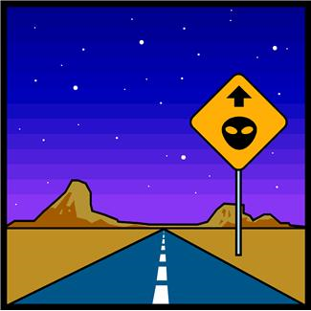 | It is dark there.  They can see many stars.  Sam stands in the middle of the desert.  Sam wants to find a purple star.  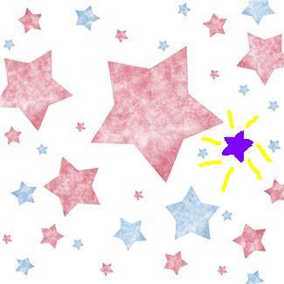
Sam sees a twinkle in the sky and smiles. He is very happy as the twinkle is a purple star.   | Sam tells his uncle to look at the purple star.  Uncle Tom is also very happy as he has never seen a purple star before.  
Sam then sees a double and triple purple star and smiles even more. 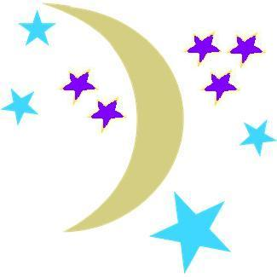 | Sam and his Uncle Tom stand in the middle of the desert for the rest of the evening looking for more double and triple purple stars.  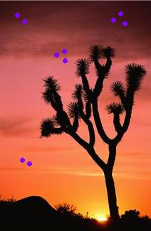

Word List
1 | 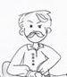 | uncle
2 |  | purple
3 |  | middle
4 |  | smile
5 |  | twinkle
6 | 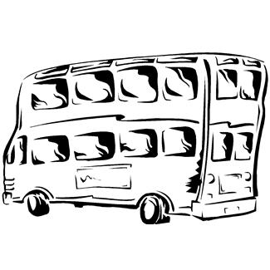 | double
7 | 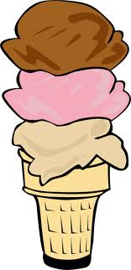 | triple
8 |  | bottle
9 |  | apple
10 |  | trouble
11 | 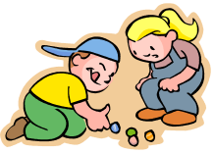 | marbles
12 | 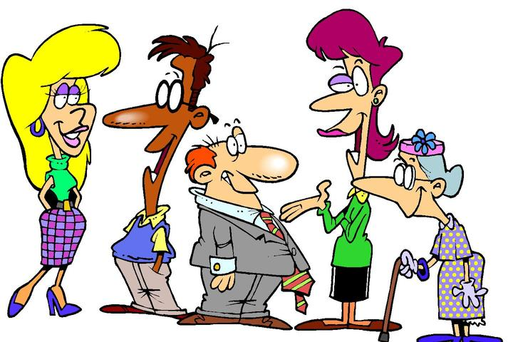 | people

Dominoes
Instructions: cut on dotted lines only. Take turns matching word to picture.

bottle |  |  | apple
purple |  |  | middle
uncle |  |  | twinkle
double |  |  | purple
triple |  |  | uncle
smile |  |  | apple
marbles |  |  | people
trouble |  |  | marbles
double |  |  | people

