Rachel's Garden
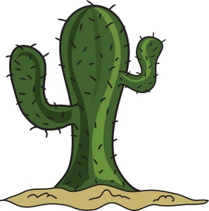Rachel had a cactus plant in her garden. |   She wanted to buy some crocus flowers to add colour* to the prickly, green cactus.
  Her dad, Septimus could not take her to the garden store. "I have a virus. I am sick." | 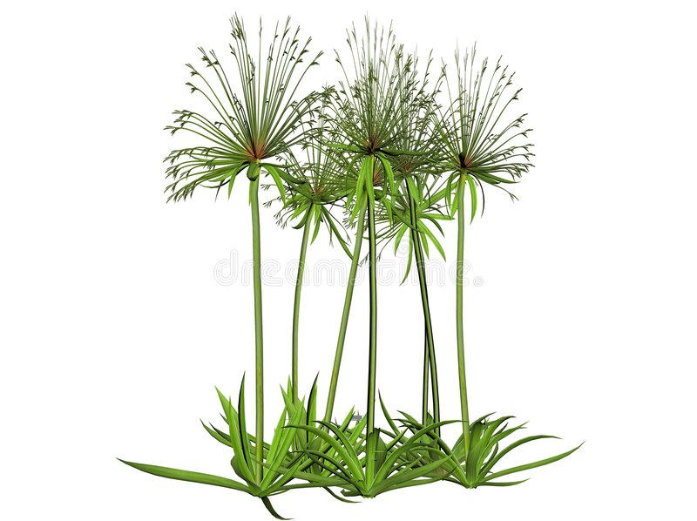Rachel decided to go alone. She bought a lotus flower and papyrus reeds.
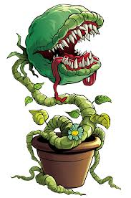  "Dad will be upset if I buy a Venus Fly Trap, too", she thought.  But she did anyway. She spent 500 NIS on her purchase. | At home, Dad yelled,  "Rachel, what have you done to us? Now, the bank will put us in minus!!!"
*colour is the British spelling, color is the American spelling
Word List
1 |  | cactus
2 |  | crocus
3 | 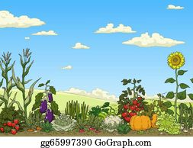 | garden
4 |  | Septimus
5 | 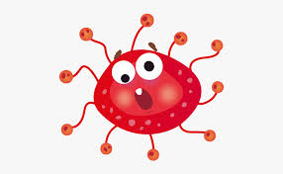 | virus
6 |  | lotus
7 |  | papyrus
8 |  | Venus
9 | 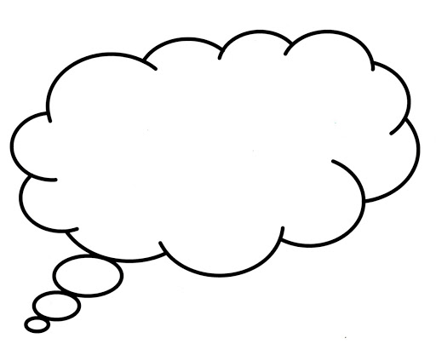 | thought
10 |  | purchase
11 | 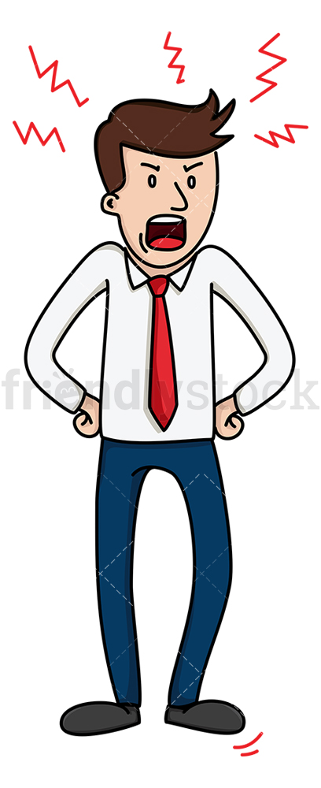 | yelled
12 | 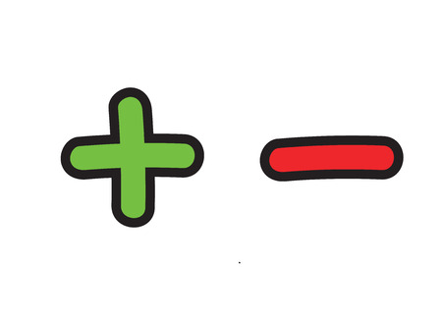 | minus

Noughts and Crosses (the British name for Tic-Tac-Toe)

Here are the rules for a Naughts (O) and Crosses (X) game.

- For a game played with printed physical elements, print and cut out the colored word cards. and the Naughts & Crosses board.

- Laminate the cards and board, shuffle and turn face down.

- The players toss a coin to decide who is O and who X

- The player who chose X goes first.

- This player picks up a card, reads it, spells it and explains the word's meaning. If the pronunciation and answer is correct, the player places a X on a square in the grid. (The -us and -ous words have the same sound ending. -ous is used for adjectives.)

- The second player, O draws a card and repeats the procedure.

- The game continues until one player has lined up THREE O's or three X's in adjacent or diagonal squares.

Online Lesson:
To play the game for an online lesson: use the shared whiteboard in Zoom to write the X’s and O’s, and use the accompanying PDF file (see link) to display the words with their pictures.

Noughts & Crosses board



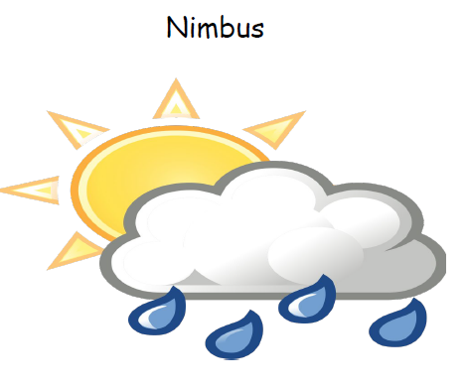 | 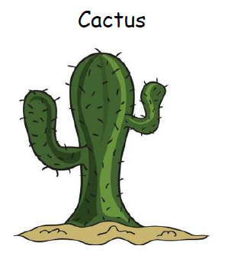
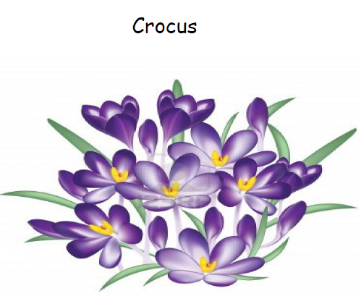 | 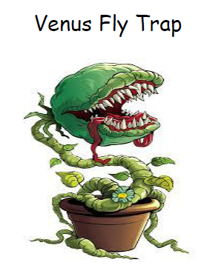
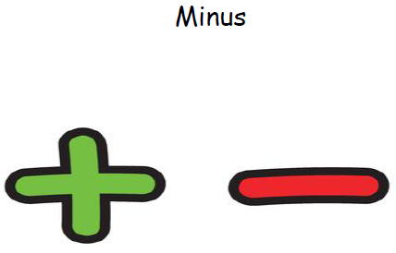 | 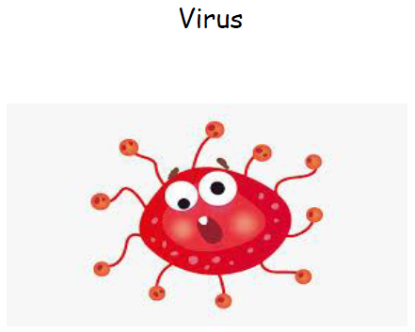
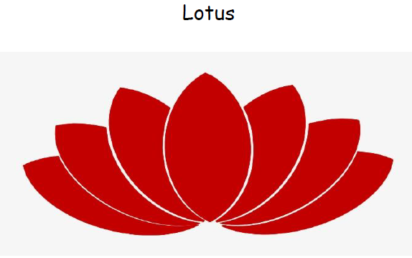 | 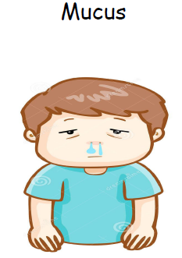
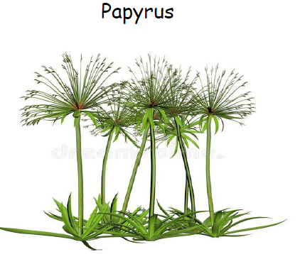 | 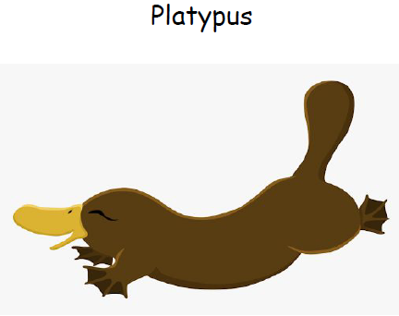
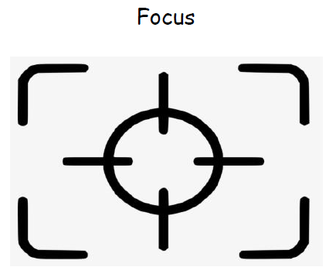 | 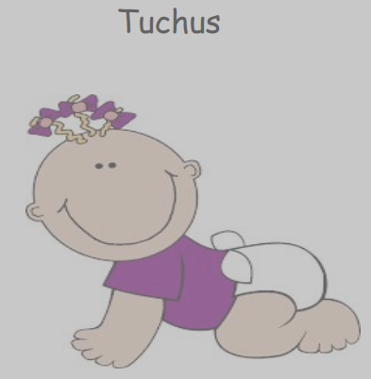  (not English!)
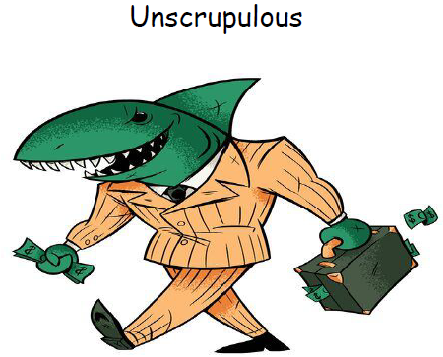  An adjective with -ous ending | 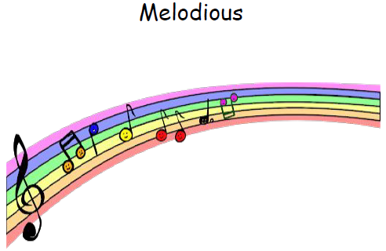  An adjective with -ous ending
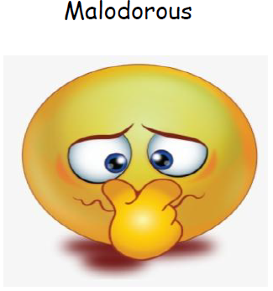  An adjective with -ous ending | 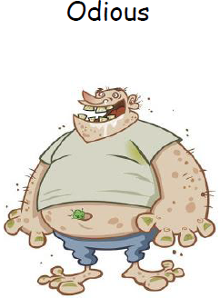  An adjective with -ous ending
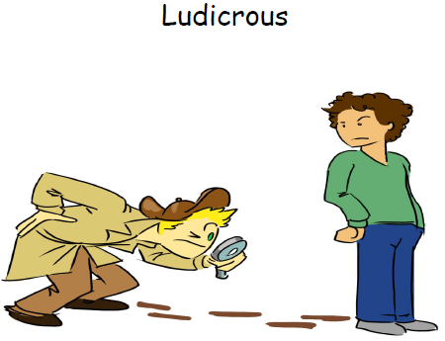  An adjective with -ous ending | 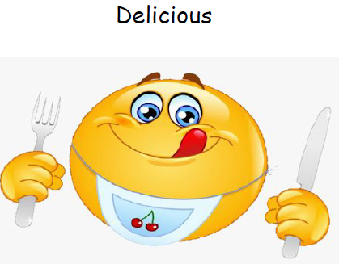  An adjective with -ous ending
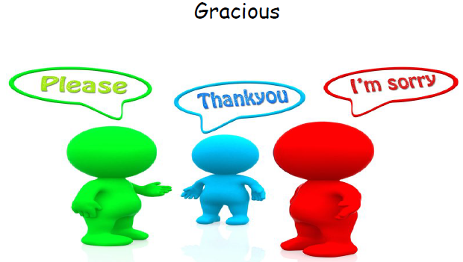  An adjective with -ous ending | 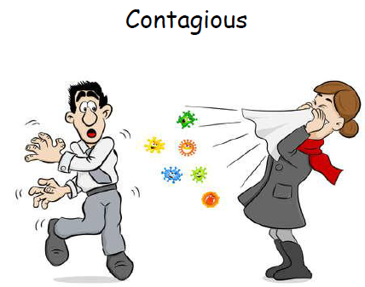  An adjective with -ous ending
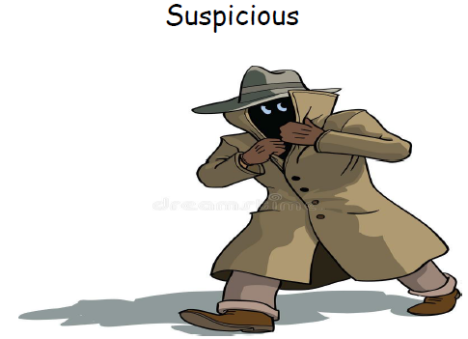  An adjective with -ous ending | 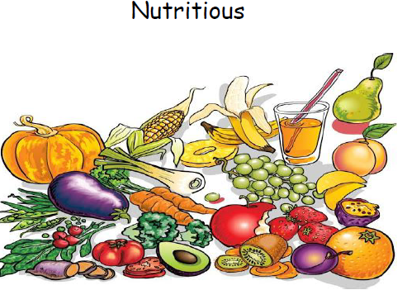  An adjective with -ous ending
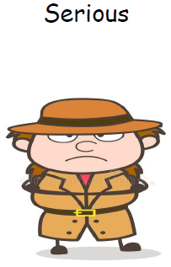  An adjective with -ous ending | 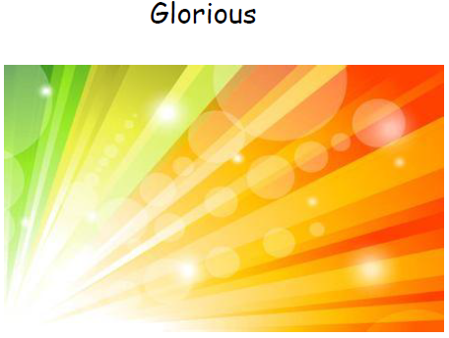  An adjective with -ous ending
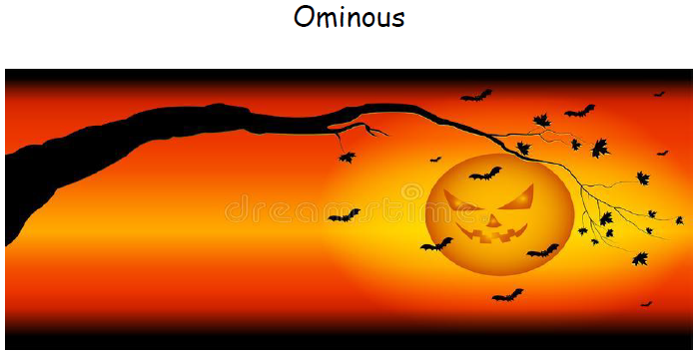  An adjective with -ous ending | Famous    An adjective with -ous ending
Obvious    An adjective with -ous ending | Various  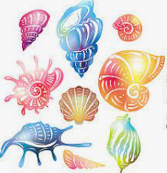  An adjective with -ous ending
Religious

An adjective with -ous ending

