Zack’s Zit
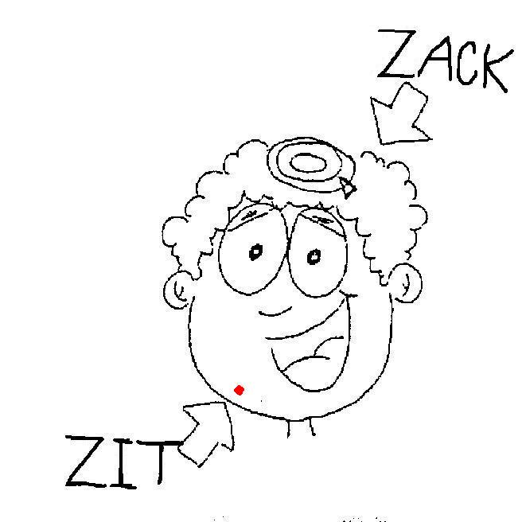  Zack has a zit. The zit is red.  The zit isn’t pretty. | 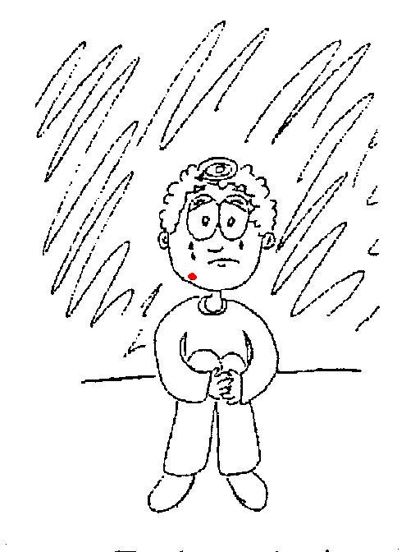  Zack is upset. Zack picks his zit. Zack zaps his zit. Zack still has his zit.  Zack is sad.
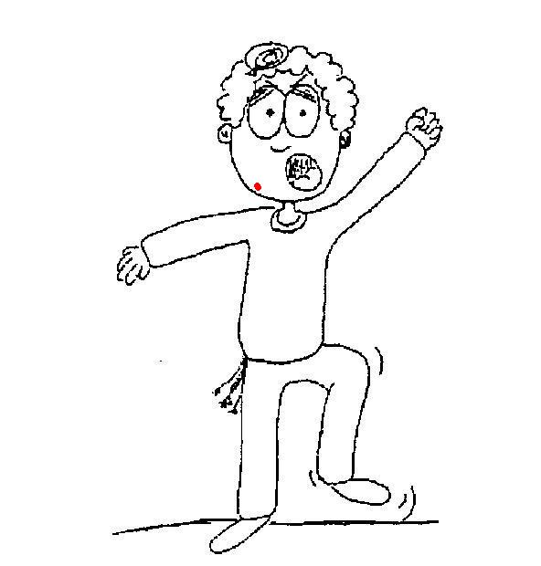  Zack is mad! The zit drives him crazy!  Zack said, “I don’t like zits!” but the zit likes Zack. | 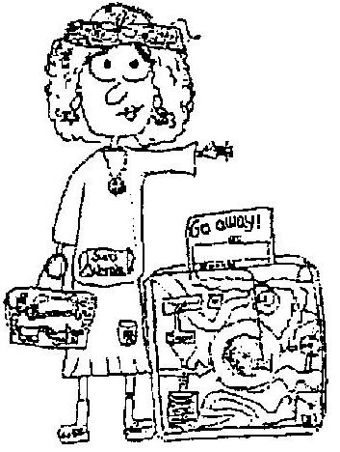  Zack hires Zelma, the Zit-Zapping Lady. Zack said, “Take my zit and I’ll give you a prize!”
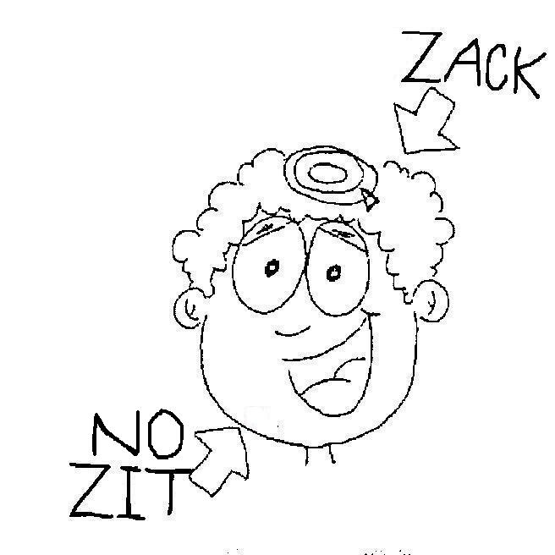  Zelma said, “Zzzzip!” and that was it! No more zit! | 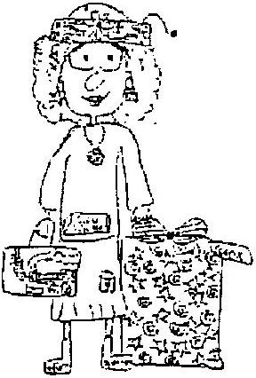  Zitless Zack gave Zelma a prize.
Word List
1 | 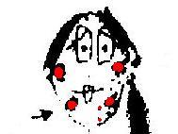 | zit
2 | 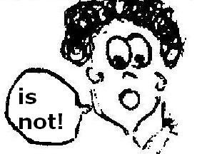 | isn’t
3 | 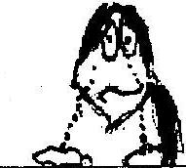 | upset
4 | 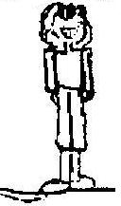 | still
5 | 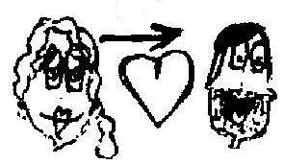 | like
6 | 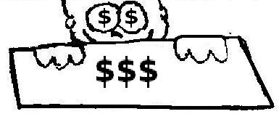 | hire
7 | 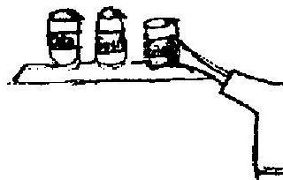 | take
8 | 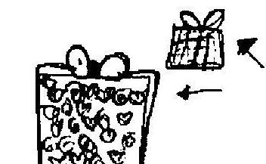 | prize
9 | 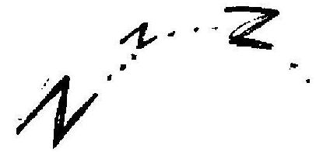 | zap
10 | 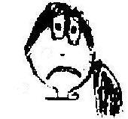 | sad
11 | 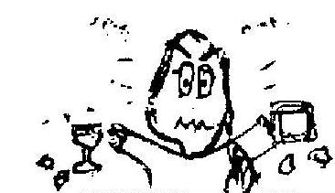 | mad
12 | 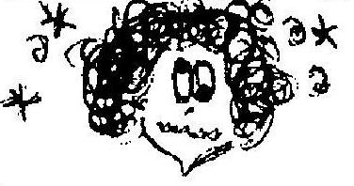 | crazy

Chutes and Ladders-Zack and Zelma
Materials: A soldier for each player, dice. Play: Each player has a turn to roll the dice and get closer to Zelma. On the way, there are words to be read, ladders to climb up, and chutes to fall down.
Objective: The winner is the one who reaches Zelma first.


