Mother Cooks Rice
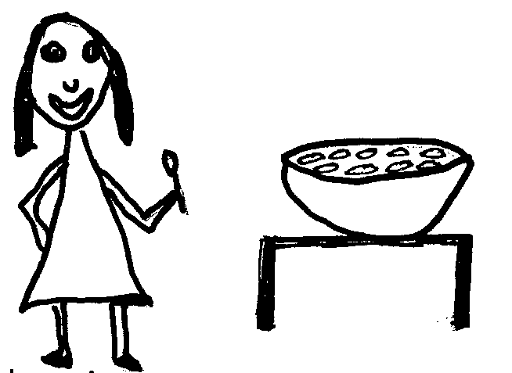  I love rice. | 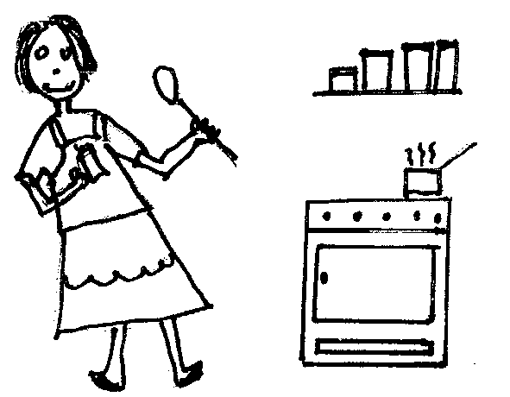  Mother cooked rice for me.  Mother added spices to the rice.  The rice was nice.
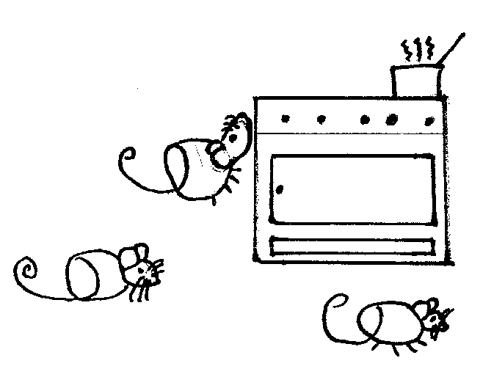  Mice like rice. | 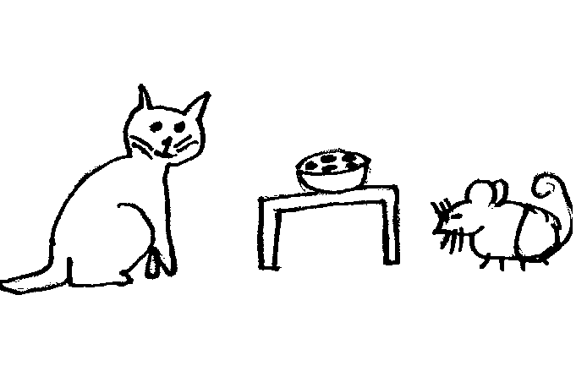  Prince, the cat, likes mice and rice.
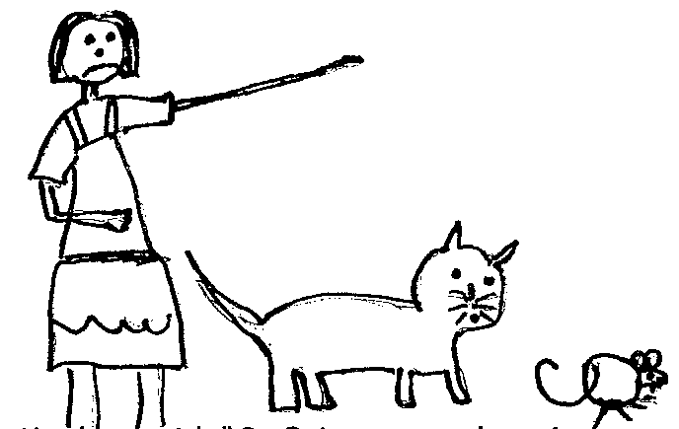Mother said, “Go, Prince, get the mice, and I will give you rice and a slice of cake.” | 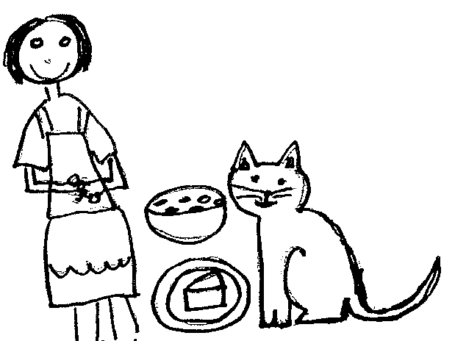No more mice! Happy Mother!  She has a smile on her face.  Happy Prince!  He has a smile on his face.

Word List
1. |  | mice
2. |  | face
3. |  | France
4. | 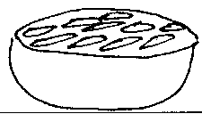 | rice
5. |  | trace
6. |  | disgrace
7. |  | slice
8. |  | nice
9. |  | glance
10. |  | prince
11. |  | ice
12. |  | advice



