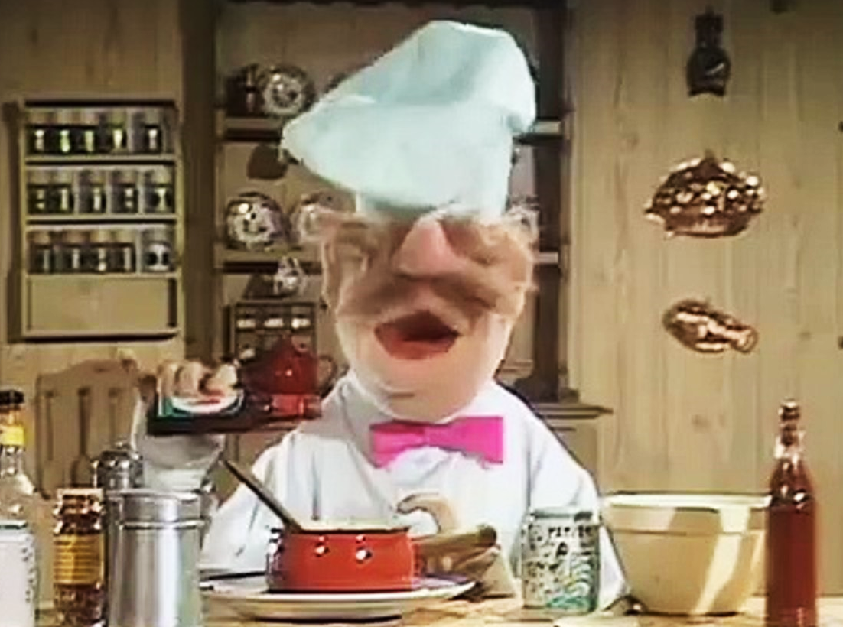  1.  The Swedish Chef wanted to take part in the "MasterChef" show, that was being filmed in Chicago. He really wanted to cook- a dish that wasn’t exactly "by the book". | 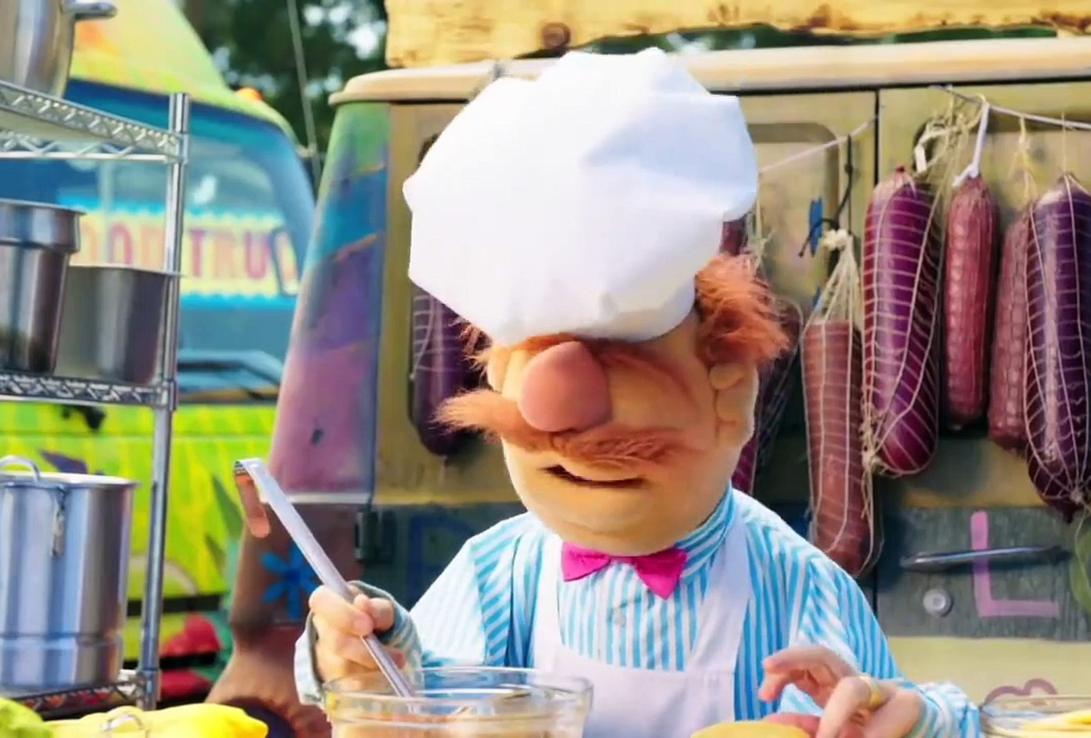  2.  2.  He tried to cook something tasty and nice,  but it turned out tasteless and it needed more spice.
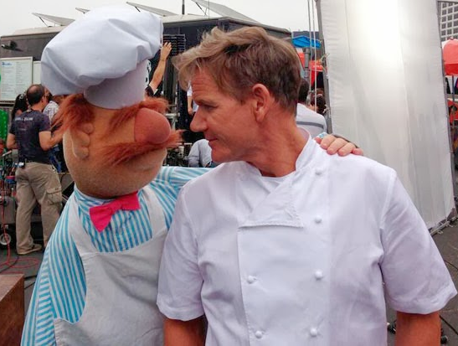  3.  The Swedish Chef then turned to his fellow chef for advice and shared with him his goal-  to win a big prize! | 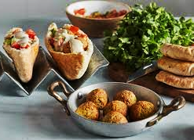  4.  Together they created a unique recipe that was probably never prepared before, a dish that the judges wouldn't be able to ignore!
  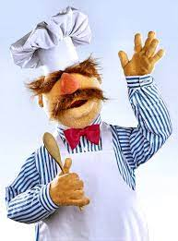  5.  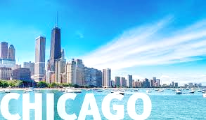  The Swedish Chef flew to Chicago, and it turned out to be a great success! He got second place, even won a prize and a bottle of champagne, and had a big smile on his face! | 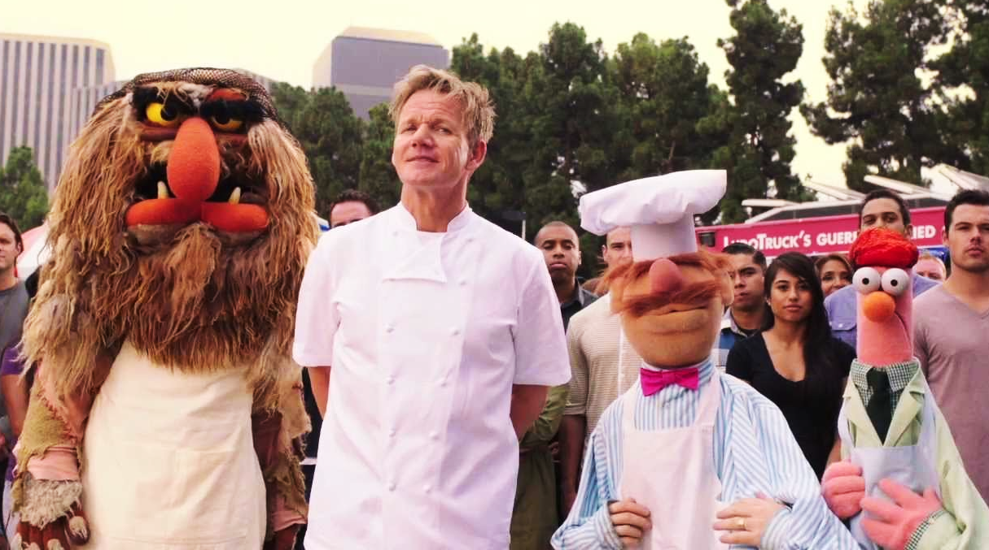  6.  But to his surprise- the prize was a shaver! The Swedish Chef's trademark was his mustache, and he really didn't need this machine, so he gave it to the chef that got third place, who seemed to need it even more than him!
The Swedish Chef

Word List

1 | 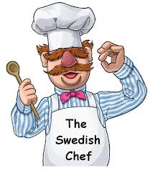 | The Swedish Chef
2 | 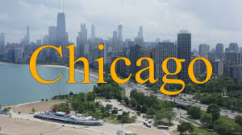 | Chicago
3 | 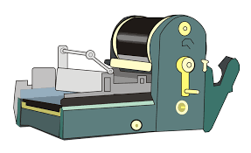 | machine
4 |  | shaver
5 |   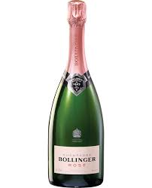 | mustache
6 | 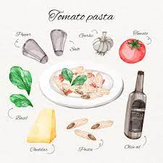 | champagne
7 |  | recipe
8 |  | trademark
9 | 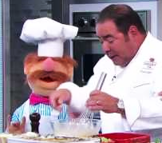 | cook
10 | 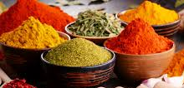 | spice
11 | 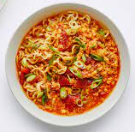 | dish
12 |  | flew

Online game-
https://wordwall.net/resource/59074951

Game 1:

Word puzzle

Fill in the words from the word list below:

 |  |  |  |  |  | S
 |  |  |  |  |  |  |  |  |  |  |  |  | F
 |  |  |  |  |  | I |  | H |  | O
 |  |  | R |  |  |  | M
 |  |  | C |  |  |  |  |  | G
 |  |  |  |  |  | A |  |  |  | H
 |  |  |  |  |  | C |  |  | C
 | A |  |  |  |  | E |  |  |  | E
 |  |  |  |  |  |  |  |  |  | R

Word list:

chef | spice | recipe | Chicago
cook | champagne | shaver | dish
flew | trademark | machine | mustache

 |  |  |  |  |  | S
 |  |  |  |  |  | P |  |  |  | C | H | E | F
 |  |  |  |  | D | I | S | H |  | O |  |  | L
 |  |  |  |  |  | C |  |  |  | O |  |  | E
 |  | T | R | A | D | E | M | A | R | K |  |  | W
 |  |  | E
 |  |  | C | H | A | M | P | A | G | N | E
 |  |  | I |  |  | U
 |  |  | P |  |  | S
 |  |  | E |  |  | T |  |  |  | S
 |  |  |  |  |  | A |  |  |  | H
 |  |  |  |  |  | C | H | I | C | A | G | O
 |  |  |  |  |  | H |  |  |  | V
M | A | C | H | I | N | E |  |  |  | E
 |  |  |  |  |  |  |  |  |  | R
Answers-

Game 2- Word search

P | E | H | C | A | T | S | U | M | T | A | B | S
S | C | L | A | O | H | J | C | X | R | S | R | H
H | H | A | H | E | N | I | H | C | A | M | E | E
A | A | K | O | O | C | H | I | B | D | A | C | F
V | M | E | P | M | H | A | C | J | E | C | I | D
E | P | E | D | O | I | E | A | S | M | E | P | I
R | A | I | I | F | F | D | G | P | A | T | E | C
C | G | P | S | L | Y | V | O | E | R | E | W | H
V | N | E | H | E | T | R | T | C | K | H | R | E
T | E | I | O | W | K | E | C | I | P | S | E | F

Answers

Answers

P | E | H | C | A | T | S | U | M | T | A | B | S
S | C | L | A | O | H | J | C | X | R | S | R | H
H | H | A | H | E | N | I | H | C | A | M | E | E
A | A | K | O | O | C | H | I | B | D | A | C | F
V | M | E | P | M | H | A | C | J | E | C | I | D
E | P | E | D | O | I | E | A | S | M | E | P | I
R | A | I | I | F | F | D | G | P | A | T | E | C
C | G | P | S | L | Y | V | O | E | R | E | W | H
V | N | E | H | E | T | R | T | C | K | H | R | E
T | E | I | O | W | K | E | C | I | P | S | E | F

WH questions- Discuss the text with your student by asking WH questions:

- What did the Swedish Chef want to do in Chicago?
- Who did he consult with regarding the dish he wanted to cook?
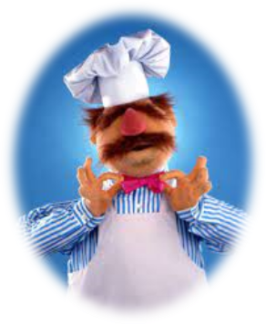
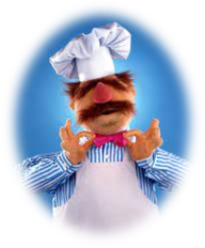
- What prizes did the Swedish Chef win?
- Where was the MasterChef show being filmed?
- Why wasn't the first dish he cooked successful?
- What is the Swedish Chef's trademark?
- Who eventually got the shaver?

Fill in the missing letters:
spi_ _
coo_ | 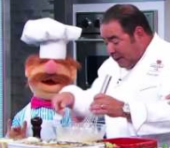
fle_
_hef
_ _ampag_e
tr_ _ _mark
re_ip_
_ _aver | 
ma_hine
_hi_ago
di_h
m_sta_he

